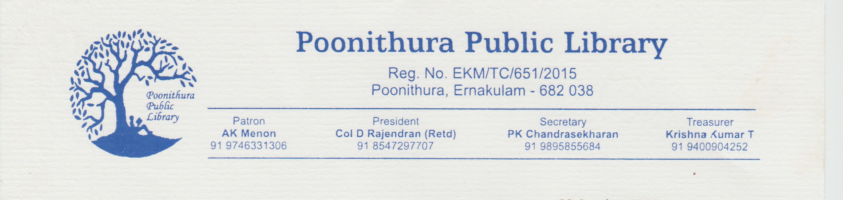
Poonithura Public Library : Digital Online Membership

We are overwhelmed to extend our digital membership for our online library collection for INR 1025 (life membership), one year membership(Rs.950),one month membership(Rs 800)

You will be able to:

Access our Digital Library from home or on the go

E-Books – Read over 70+ full text e-books ,novels (in English and Malayalam) and audio books(10).This includes academic ,fiction, technical, management ,engineering and for competitive examinations)

E-Magazines - Read our modest collection of magazines

E-Movies - Watch educational videos ,short feature films and documentaries.

E-Newspapers - Read our vernacular and English and Malayalam e-newspaper collection.

E-Learning - Access online learning courses on soft skills ,english, and self publishing.

Secretary
Poonithura Public Library

